GuardianAI
User Flow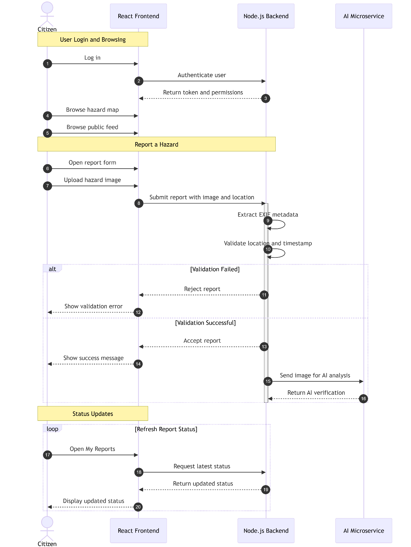

Image Processing and AI Detection Workflow
When a citizen's image is successfully validated (i.e., the GPS location and timestamp are verified), it is forwarded to the Python/Flask ML Microservice for image analysis. The following sequence of image processing and AI-based object detection is performed.

1. Image Preprocessing (Handling Real-World Conditions)
Images captured by citizens may be affected by varying lighting conditions, shadows, glare, or adverse weather. Therefore, the system first enhances the image before performing object detection.
Contrast Enhancement (CLAHE)
The image undergoes Contrast Limited Adaptive Histogram Equalization (CLAHE) to improve visibility.
This process:
- Enhances local image contrast.
- Reveals details hidden in dark or overexposed regions.
- Produces a more balanced image for AI analysis.
Image Sharpening
After contrast enhancement, a sharpening kernel is applied to the image.
The sharpening process:
- Enhances object boundaries.
- Improves edge definition.
- Makes infrastructure defects such as potholes, cracks, and broken streetlights more distinguishable.
The enhanced image is then forwarded to the object detection model.

2. AI Inference (Object Detection)
The preprocessed image is analyzed using a deep learning object detection model.
YOLOv8 Object Detection Model
The system utilizes a custom-trained Ultralytics YOLOv8 model stored as:
civic_v1.pt
This model has been specifically trained to recognize common urban infrastructure hazards.
Hazard Detection and Classification
The YOLOv8 model scans the image to:
- Detect infrastructure defects.
- Generate bounding boxes around detected objects.
- Classify each detected object into the appropriate hazard category.
Examples of supported hazard categories include:
- Pothole
- Garbage Dump
- Water Leak
- Broken Streetlight
- Road Damage
- Other civic infrastructure issues
Each detected object is assigned a confidence score indicating the model's prediction certainty.

3. Confidence Filtering
To minimize false detections and improve prediction reliability, the system applies a confidence threshold.
Confidence Threshold
Only detections with a confidence score of 0.30 (30%) or higher are considered valid.
The filtering process works as follows:
- Confidence ≥ 0.30 → Detection is accepted.
- Confidence < 0.30 → Detection is discarded.
This filtering mechanism helps reduce false positives while maintaining reliable hazard detection.

4. Returning the Detection Results
After completing object detection and confidence filtering, the ML Microservice prepares the final detection results.
The response includes:
- Detected hazard categories.
- Confidence scores.
- Bounding box coordinates for each detected object.
These results are sent back to the Node.js Core API for further processing.
Backend Processing
Upon receiving the detection results, the backend:
- Updates the citizen's report in the database.
- Assigns the appropriate hazard category.
- Routes the complaint to the responsible municipal department or worker.
- Determines the appropriate Service Level Agreement (SLA) based on the detected hazard type.
This automated workflow enables accurate issue classification, efficient complaint routing, and timely resolution of reported civic infrastructure problems.
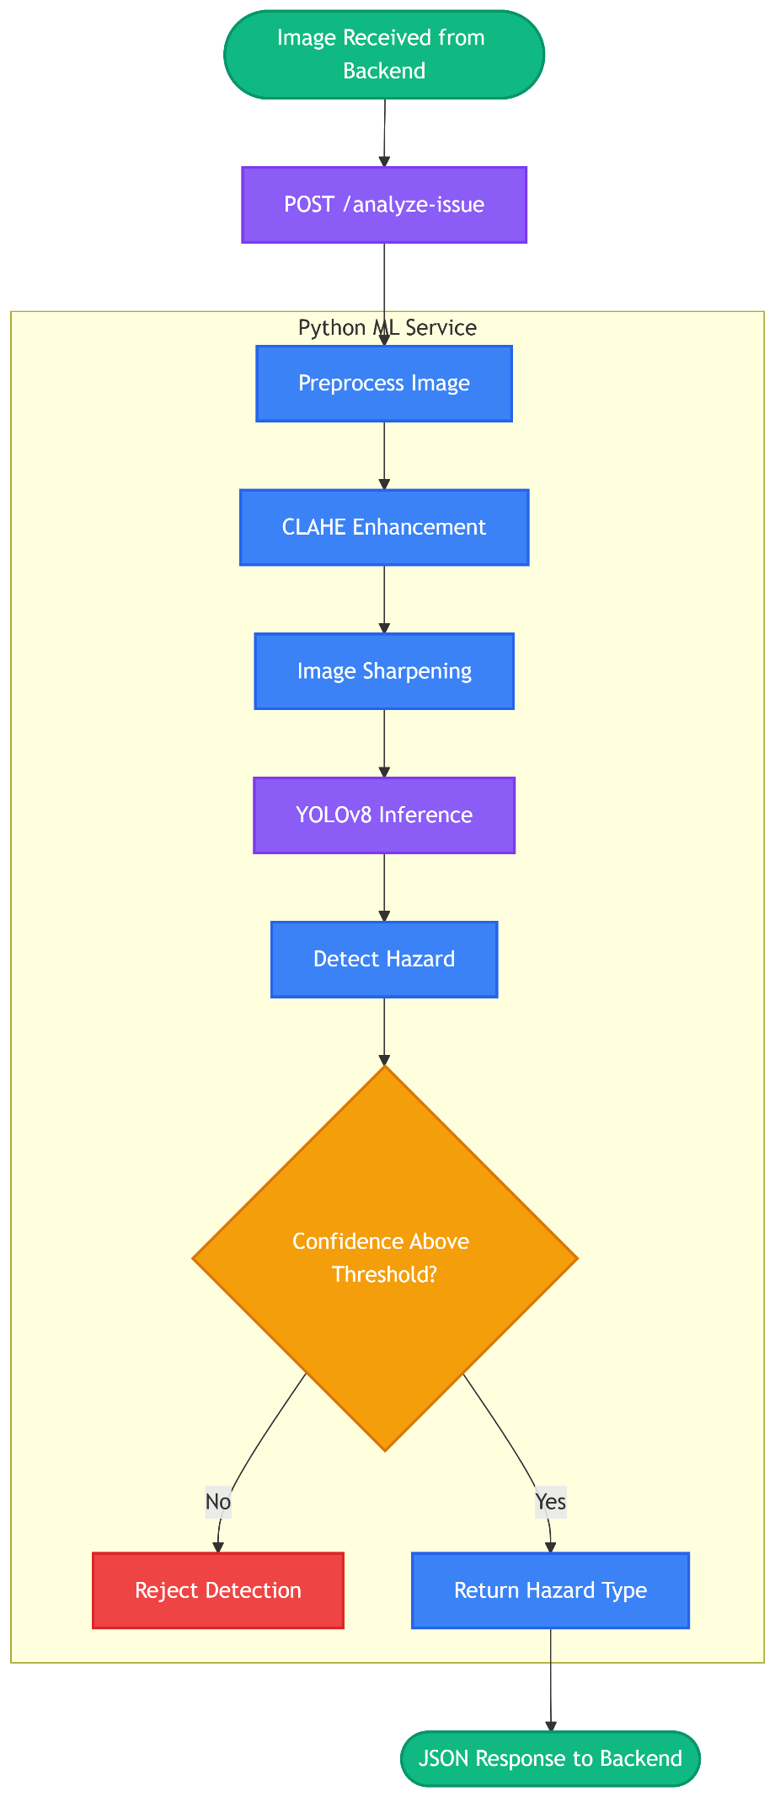
Worker Flow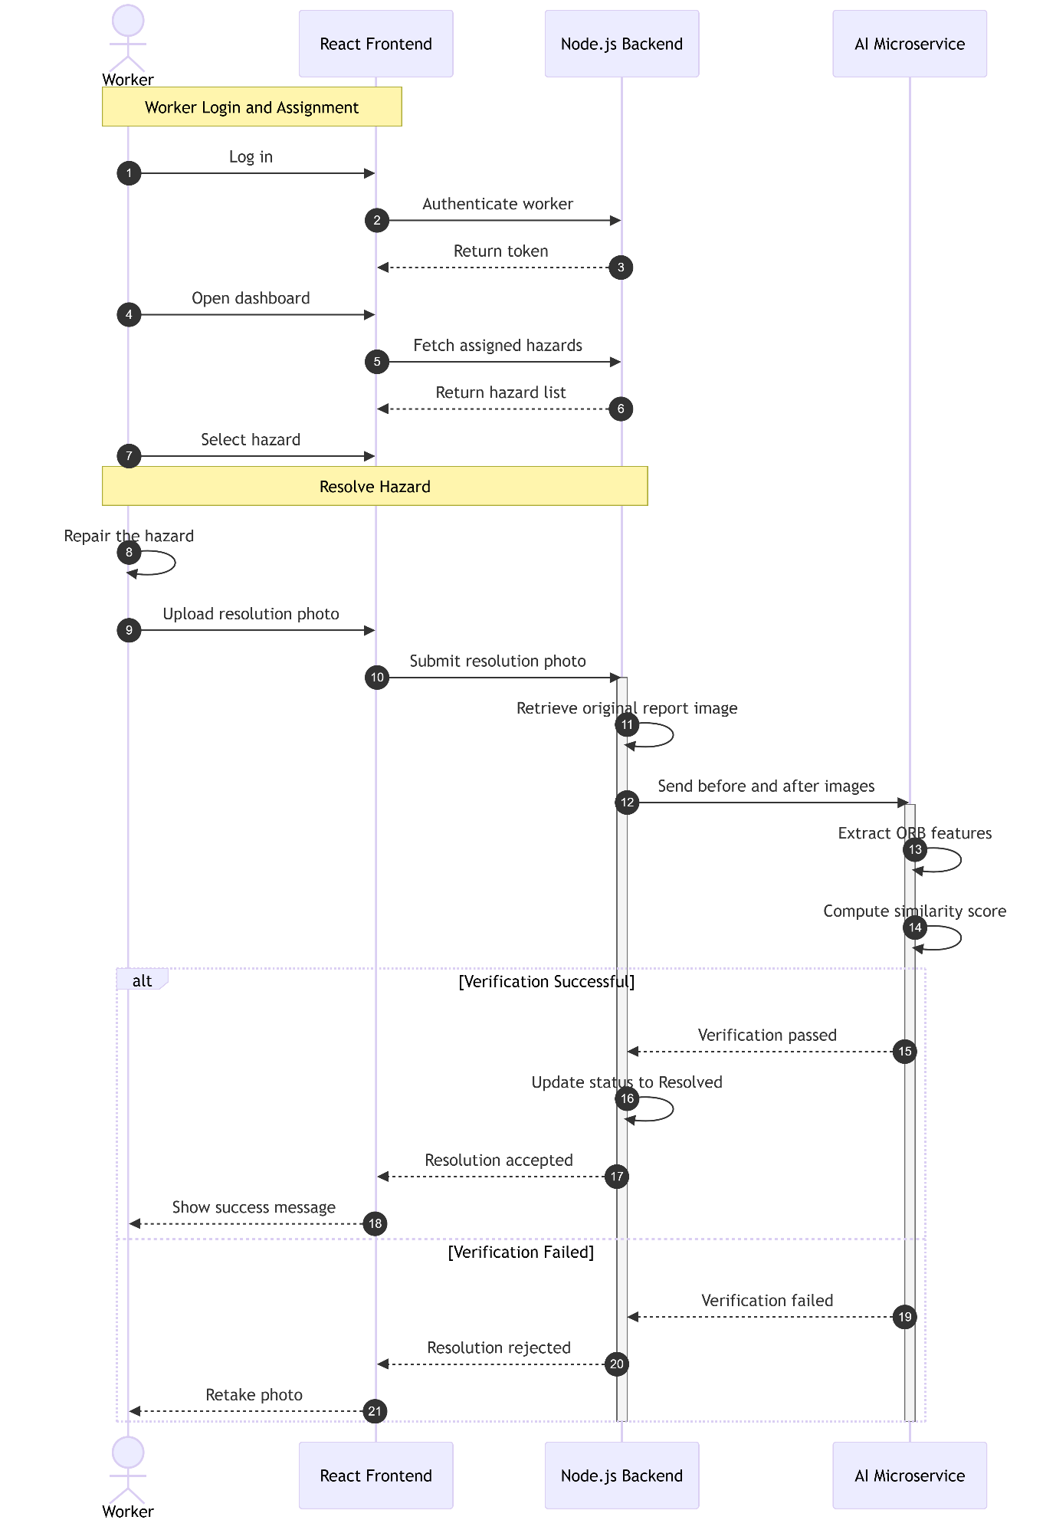

Resolution Verification Workflow
When a city worker completes a repair and uploads a resolution ("after") image, the system initiates a multi-stage AI verification process to confirm that the reported hazard has been resolved at the correct physical location.
This verification workflow spans both the Node.js backend and the Python/Flask ML Microservice, ensuring that only genuine repairs are accepted while preventing fraudulent job completions.

1. Payload Reception and Backend Orchestration
The verification process begins when the worker submits a resolution image to the Node.js Core API.
The request is handled by the updateComplaintStatus function in backend/src/controllers/complaints.js, which acts as the central orchestrator for the entire verification workflow.
Complaint Retrieval
The controller retrieves the original complaint from MongoDB, including:
- Original ("Before") image submitted by the citizen.
- Original GPS coordinates of the reported hazard.
- Complaint metadata required for verification.

2. GPS Validation and Metadata Verification
Before any AI processing is performed, the backend validates the worker's location to ensure that the resolution photo was captured near the reported hazard.
This functionality is implemented in:
backend/src/services/gpsValidator.js
Distance Calculation
The system uses the Haversine Formula through the calculateDistanceMeters() function to compute the distance between:
- Original complaint location.
- Worker's current GPS location.
GPS Threshold
If the worker is located more than 500 meters away from the original complaint location:
- The request is immediately rejected.
- The complaint status is updated to REJECTED_GPS.
- No Machine Learning resources are consumed.
This early validation prevents unnecessary AI processing.
EXIF Metadata Validation
The validateGPSData() function uses the exifr library to extract EXIF metadata directly from the uploaded image.
This metadata provides an additional verification layer by:
- Reading embedded GPS information.
- Extracting image capture metadata.
- Supporting auditability of uploaded resolution images.

3. ML Verification Request
If GPS validation succeeds, the backend prepares an AI verification request.
The updateComplaintStatus controller packages:
- Original ("Before") image.
- Worker's resolution ("After") image.
The images are sent through an HTTP POST request to the Python ML Microservice endpoint:
/verify-resolution

4. ML API Routing (Python/Flask)
The verification request is received by the Flask application through the:
/verify-resolution
route implemented in:
ml/ml_api.py
This component functions as a lightweight API router.
Its responsibilities include:
- Receiving the JSON payload.
- Extracting the before and after image data.
- Forwarding the images to the core visual verification engine.
No image processing or AI inference occurs at this stage.

5. AI-Based Resolution Verification
The core verification logic is implemented in:
ml/src/visual_detector.py
using the function:
verify_resolution_images()
The verification process consists of three major stages.
5.1 Background Verification (ORB Feature Extraction)
Direct image comparison is unreliable because photographs are often captured under different conditions, including:
- Different lighting
- Different weather
- Different camera angles
- Different times of day
Instead of comparing raw pixels, the system compares permanent background structures.
The verification engine calls:
calculate_background_similarity()
which uses OpenCV ORB (Oriented FAST and Rotated BRIEF) feature extraction.
For each image, the algorithm extracts up to 1,000 keypoints, including:
- Corners
- Edges
- Building structures
- Road markings
- Sidewalk boundaries
- Permanent architectural features
The extracted descriptors are matched between the citizen's "before" image and the worker's "after" image to compute a Background Match Score.

5.2 Hazard Detection (YOLOv8 Inference)
The verification engine next performs object detection on both images.
The function:
perform_object_detection()
first applies image enhancement to improve detection quality.
Image Preprocessing
Each image undergoes:
- CLAHE (Contrast Limited Adaptive Histogram Equalization) for adaptive contrast enhancement.
- Sharpening Kernel to improve edge definition.
These preprocessing steps improve detection performance under varying lighting conditions.
Object Detection
The enhanced images are analyzed using a custom-trained Ultralytics YOLOv8 model:
civic_v1.pt
The model detects civic infrastructure hazards such as:
- Potholes
- Garbage Dumps
- Water Leaks
- Broken Streetlights
- Road Damage
- Other supported hazard categories
Only detections with a confidence score of 0.30 (30%) or higher are retained.

5.3 Final Decision Matrix
After obtaining both the Background Match Score and the object detection results, the verification engine applies a strict decision matrix.
A resolution is considered verified when:
- The Background Match Score is greater than or equal to 0.45, confirming that both images were captured at the same physical location.
- The original ("before") image contains one or more detected hazards.
- The resolution ("after") image contains no remaining detected hazards.
Under these conditions, the system returns the label:
VERIFIED_RESOLUTION
If these conditions are not satisfied, the verification engine returns an appropriate rejection label, such as:
REJECTED_ML
This logic ensures that both the location and the successful removal of the hazard are verified before accepting a repair.

6. Final Verification and Database Update
The ML Microservice returns the verification result and associated confidence information to the Node.js Core API.
The updateComplaintStatus controller then performs the final workflow.
Successful Verification
If the AI returns VERIFIED_RESOLUTION, the backend:
- Accepts the worker's resolution image.
- Uploads the verified image to Cloudinary.
- Updates the complaint document in MongoDB.
- Changes the complaint status to Resolved.
- Records the verification result.
- Triggers a public notification indicating that the reported hazard has been successfully resolved.
Failed Verification
If the AI returns REJECTED_ML, or if the earlier GPS validation resulted in REJECTED_GPS, the backend:
- Rejects the resolution submission.
- Updates the complaint status accordingly.
- Returns an error response to the frontend.
- Requests the worker to capture a clearer image from the correct location and from an angle similar to the original citizen report.
This multi-stage verification pipeline combines GPS validation, EXIF metadata extraction, ORB-based background matching, and YOLOv8 object detection to ensure that only genuine repairs performed at the correct location are accepted into the GuardianAI system.
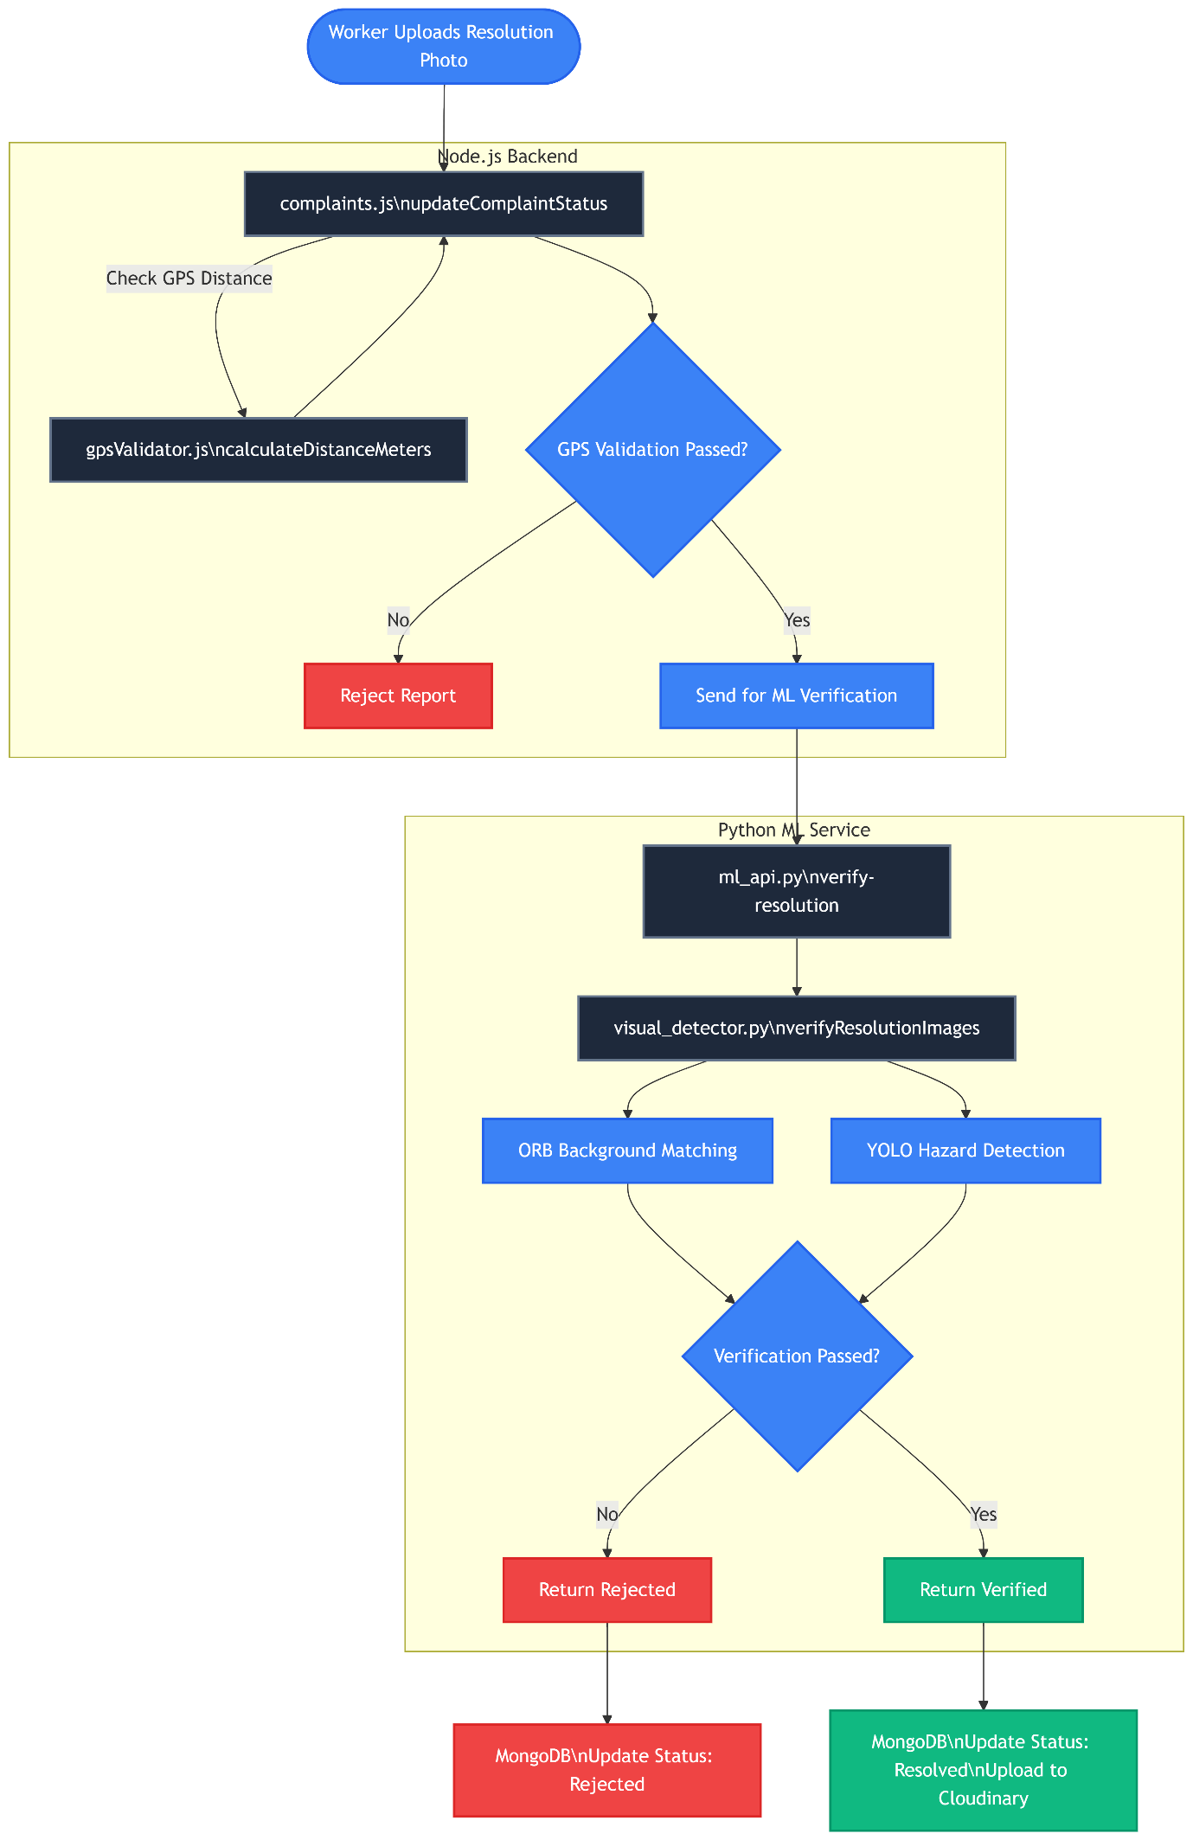
Autority Flow